Experiment worksheet

8.1 Earth’s gravity pulls objects to the centre of the Earth

Pages 144–145 and 210

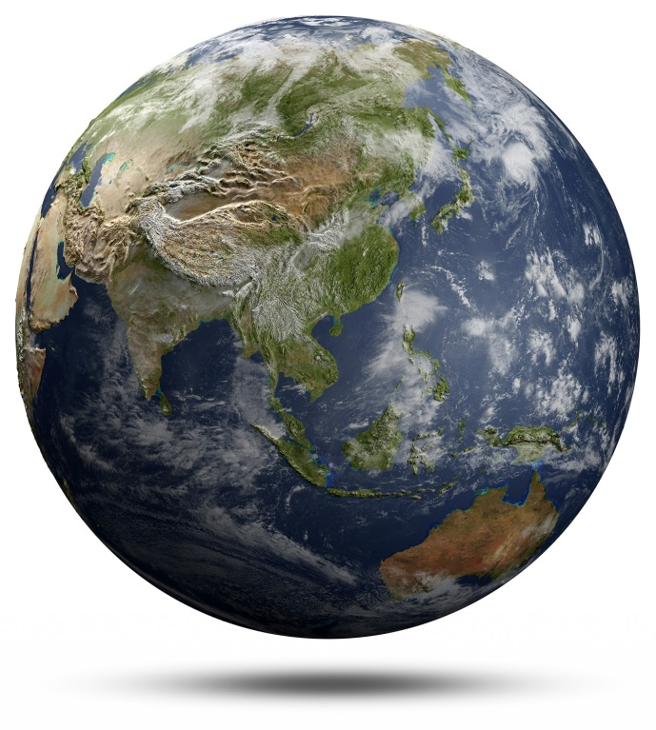Skills Lab 8.1: Calculate weights in the solar system

The effects of gravity are affected by the mass of the objects involved. Gravity on the Earth is determined by the mass of Earth. How this gravity affects objects on the Earth is determined by their mass.

By doing some simple calculations, you can work out what your weight would be if you lived on the Sun, on other planets in the solar system or on the Moon. Note that the Earth has a gravity factor of 1, which is often referred to as 1*g*. To calculate weight, you will need to multiply mass (the reading on the bathroom scales) by the gravity factor for the planet, Sun or Moon. Remember that weight is measured in newtons.

1 Using the Earth’s gravity factor, calculate the weight of a 65 kilogram person on the Earth and record it in the table below (in the first row).

2 Complete the table below, filling in the weight for the 65 kilogram person on the other planets, the Sun and the Moon.

|  |  |  |  |
| --- | --- | --- | --- |
| Planet | Gravity Factor | Person’s Mass (kg) | Person’s weight (N) |
| Earth | 1.00 | 65.00 |  |
| Mercury | 0.38 | 65.00 |  |
| Venus | 0.90 | 65.00 |  |
| Mars | 0.38 | 65.00 |  |
| Jupiter | 2.87 | 65.00 |  |
| Saturn | 1.07 | 65.00 |  |
| Uranus | 0.93 | 65.00 |  |
| Neptune | 1.23 | 65.00 |  |
| Sun | 27.80 | 65.00 |  |
| Moon | 0.16 | 65.00 |  |

3 Imagine holding an Olympic Games on the different astronomical bodies listed in the table. Based on your calculations, do you think the gravity factor for the planet would affect the results of the events? For example, would diving or high jump be affected? What about other events?

4 How would gravity affect your lifestyle on Mercury compared with Jupiter?

5 What everyday tasks would be easier or harder? Explain.

Experiment worksheet

8.2 Gravity keeps planets in orbit around the sun

Pages 146–147 and 211

Challenge 8.2: Modelling gravity in the solar system

What you need:

1 small hula hoop, 1 thin stretchable plastic sheet (i.e. garbage bag or cling wrap), 2–4 small marbles, one 5 cm Styrofoam ball, ½ cup of play dough

What to do:

Many scientists describe the gravitational field in space as acting like a trampoline. If the trampoline is flat, a marble is able to roll straight across the surface, much like an asteroid through empty space. If the trampoline is not flat because a brick is sitting on it, then the marble will curve around the object as it rolls along, much like an asteroid curves around a planet as it moves through the solar system.

You can mimic this using the hula hoop to represent space.

1 Cover the hula hoop with the thin sheet of plastic.

2 Suspend your model universe on books or bricks.

3 Roll a marble across the tight plastic sheet. Describe its movement.

4 Place two marbles on the plastic sheet. Describe how the two marbles move.

5 Place the rounded ½ cup of play dough in the centre of the plastic sheet.

6 Describe what happens when the marbles are now dropped onto the sheet.

7 Replace the play dough with the Styrofoam ball. Describe the motion of the marbles when they are dropped onto the sheet a second time.

Questions

1 In your model, how was gravity represented?

2 Which had the strongest ‘gravitational pull’, the play dough ball or the Styrofoam ball? What evidence do you have to support your answer?

3 What type of object in the solar system could the Styrofoam ball represented? (Hint: large and low density.)

4 Black holes are space objects with such a strong gravitational field that nothing can escape them. Why are they called *black* holes?